PROBABILITY AND STATISTICS



CASE STUDY
ON

STUDY OF RELATION BETWEEN ROAD

ACCIDENTS AND BAD WEATHER CONDITIONS

BY
O.PRUDHVI TEJA 2203A51577
G.THARUN 2203A51567
P.MEGHANTH RAO 2203A51578
P.SUNNY 2203A51511
E.SAI DEEKSHITH 2203A51564
A.ROHAN 2203A51537
UNDER THE GUIDENCE OF
DR. G.RAVI KIRAN

SUBMITTED TO

Department of mathematics
SR University, Ananthasagar, Hanamakonda


Question: Do the bad weather conditions increase the no. of road accidents?
▪ Collect a sample of road accidents occurred due to heavy rain fall. (both quantity of rainfall and the number of accidents is to be collected)
▪ Find the coefficient of correlation between the rain fall and accidents.
▪ Construct a quadratic regression curve suitable for the data collected.

Here is the collection of scores of a sample of students in ‘Introduction to Programming’ course both theoretical and practical exams.

SERIAL  NUMBERS | No. of  Accidents | Temperature  of the day
1 | 2 | 30
2 | 3 | 27
3 | 5 | 24
4 | 1 | 25
5 | 4 | 22
6 | 2 | 22
7 | 1 | 23
8 | 4 | 24
9 | 2 | 25
10 | 1 | 23

X=[2+3+5+1+4+2+1+4+2+1]/10
=25/10
=2.5

y=[30+27+24+25+22+22+23+24+25+23]/10
=245/10
=24.5

CORELLATION COEFFICIENT BETWEEN ROAD ACCIDENTS & WEATHER CONDITIONS
Let x be road accidents and y be the bad weather conditions
x | X=  (x-x) | X^2 | y | Y=  (y-y) | Y^2 | XY
1 | -0.5 | 0.25 | 30 | 5.5 | 30.25 | -2.75
2 | 0.5 | 0.25 | 27 | 2.2 | 6.25 | 1.25
3 | 2.5 | 6.25 | 24 | -0.5 | 0.25 | -1.25
4 | -1.5 | 2.25 | 25 | 0.5 | 0.25 | -0.75
5 | 1.5 | 2.25 | 22 | -2.5 | 6.25 | 3.75
6 | -0.5 | 0.25 | 22 | -2.5 | 6.25 | 1.25
7 | -1.5 | 2.25 | 23 | -1.5 | 2.25 | 2.25
8 | 1.5 | 2.25 | 24 | -0.5 | 0.25 | -0.75
9 | -0.5 | 0.25 | 25 | 1.5 | 0.25 | -0.75
10 | -1.5 | 2.25 | 23 | -1.5 | 0.25 | 0.25

CORRELATION COEFFICIENT:
The degree of relationship between the variables under consideration is measured through the correlation analysis.
The extended degree of relationship between the two variables is measured in terms of another parameter called coefficient of correlation.
Coefficient of correlation is denoted by “r”. The value of r lies between -1 and 1, i.e., −1 r 1. From the above table
from the above bable
ΣX = 25
ΣΥ = 245
AX = 2.5
Y = 24.5
ΣXY = -2.5
ΣX^2 = 18-5
ΣΥ^2 = 54.5
Correlation Coefficient r = Σ XY
Σ X^2 *ΣY^2
= -2.5
(18.5)*(54.5)
= -0.248975

Hence the correlation coefficient between the road accidents and bad weather conditions is
CODE:
import numpy as np
data1=np.array([2,3,5,1,4,2,1,4,2,1])
data2=np.array([30,27,24,25,22,22,23,24,25,23])
x_bar=np.mean(data1)
y_bar=np.mean(data2)
nr=sum((data1-x_bar) *(data2-y_bar))
dr=np.sqrt(sum((data1-
x_bar)**2)*sum((data2-y_bar)**2))
corr=nr/dr
print("The correlation coefficient is",corr)
OUTPUT:


Construct a quadratic regression curve suitable for the data collected.
X1=2,3,5,1,4,2,1,4,2,1
Y1=30,27,24,25,22,22,23,24,25,23
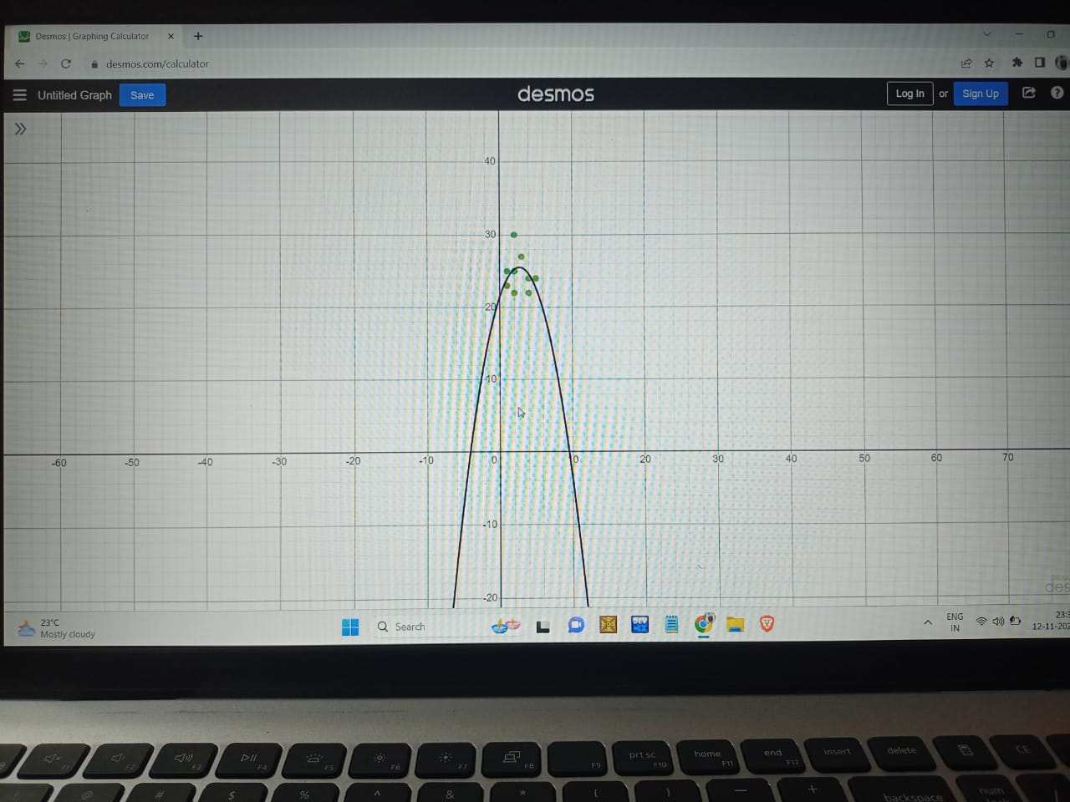
Y1=ax1^2+bx1+c
a=-0.547323
b=2.9565
c=21.5421
Y1=-0.5473x1^2+2.9565x1+21.5421
Code:
import numpy as np
import matplotlib.pyplot as plt
from numpy.polynomial import Polynomial
from scipy.stats import linregress
rainfall = np.array([your rainfall data])
accidents = np.array([your accidents data])
coefficients = np.polyfit(rainfall, accidents, 2)
quadratic_curve = np.poly1d(coefficients)
print("Quadratic Regression Equation:")
print(quadratic_curve)
plt.scatter(rainfall, accidents, label='Data Points')
plt.plot(rainfall, quadratic_curve(rainfall), color='red', label='Quadratic Regression Curve')
plt.xlabel('Rainfall')
plt.ylabel('Accidents')
plt.legend()
plt.show()
output:
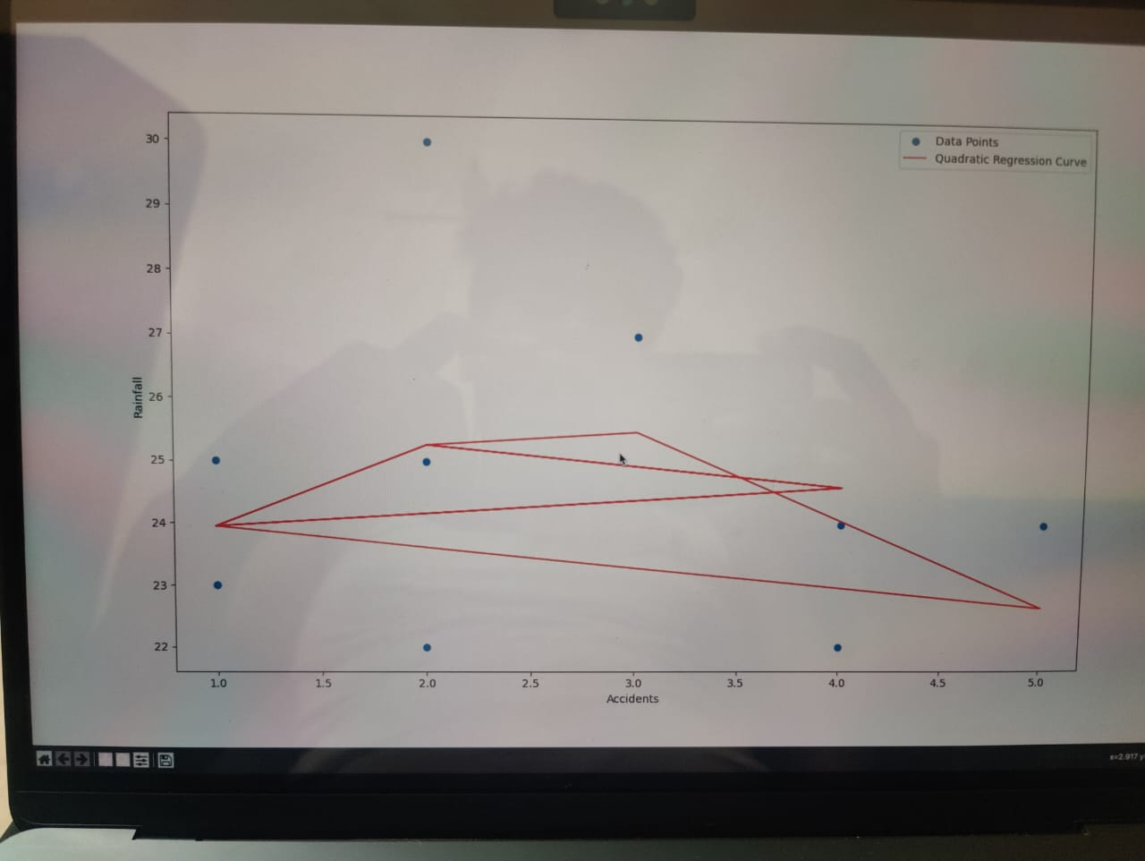
REFERENCE:
These are the references which are collected from the random hospitals
